**PROJECT REPORT**

**Predicting Defaulter on Credit-Industry Data**

*Submitted towards the partial fulfillment of the criteria for award of Genpact Data Science Prodegree by Imarticus*

*Submitted By:*

*Abhinav Rana*

*Course and Batch:*

*Data Science Prodegree - Online*

*DSP-28*

*January-2020*



# Abstract

**Keywords**

*Disclaimer: *Data shared by the customer is confidential and sensitive, it should not be used for any purposes apart from capstone project submission for DSP. The Name and demographic details of the enterprise is kept confidential as per their owners’ request and binding.*

# Acknowledgements

We are using this opportunity to express my gratitude to everyone who supported us throughout the course of this group project. We are thankful for their aspiring guidance, invaluably constructive criticism and friendly advice during the project work. I am sincerely grateful to them for sharing their truthful and illuminating views on a number of issues related to the project.

Further, we were fortunate to have Mr. Kunal as our mentor. He has readily shared his immense knowledge in data analytics and guide us in a manner that the outcome resulted in enhancing our data skills.

We wish to thank, all the faculties, as this project utilized knowledge gained from every course that formed the DSP program.

We certify that the work done by us for conceptualizing and completing this project is original and authentic.

Date: June 20, 2020 Abhinav Rana

Place: Mumbai

# Certificate of Completion

I hereby certify that the project titled “Predicting Defaulter on Credit-Industry Data” was undertaken and completed under my supervision by Abhinav Rana from the batch of DSP-28(January-2020)

Date: June 20, 2020

Place – Dhampur

Table of Contents [Sample purpose only]

Abstract 3

Acknowledgements 3

Certificate of Completion 4

CHAPTER 1: INTRODUCTION 6

1.1 Title & Objective of the study 6

1.2 Need of the Study 6

1.3 Business or Enterprise under study 6

1.4 Data Sources 6

1.5 Tools & Techniques 6

CHAPTER 2: DATA PREPARATION AND UNDERSTANDING 7

2.1 Phase I – Data Extraction and Cleaning: 7

2.2 Phase II - Feature Engineering 8

 9

2.4 Exploratory Data Analysis: 9

CHAPTER 3: FITTING MODELS TO DATA 12

3.1.1 Logistic Regression: 12

3.1.2 XGBOOST ALGORITHM: 13

3.1.3 Random Forest Classifier: 13

3.1.4 Decision Tree Classifier: 13

CHAPTER 5: KEY FINDINGS 14

CHAPTER 6: RECOMMENDATIONS AND CONCLUSION 14

CHAPTER 7: REFERENCES 14

Imarticus 14

Towardscience 14

Wikepedia 15

Analytic vidhya blog 15

# CHAPTER 1: INTRODUCTION

## Title & Objective of the study

Title: - Predicting Defaulter on Credit-Industry Data

Objective: - To build a data model to predict the probability of default, and choose a cut-off based on what you feel is suitable. Alternatively you can also use a modelling technique which gives binary output. Based on the data that is available during loan application, build a model to predict default in the future. This will help the company in deciding whether or not to pass the loan. Also note that the data contains defaulters, successful payers and customers who were current during that time. To simplify the problem, customers under 'current' status have been considered as non-defaulters in the dataset.

## Need of the Study

The main goal of this project is to use the data of XYZ corp. to predict default in the future. This will help the company in deciding whether or not to pass the loan

## Business or Enterprise under study

* Credit Industry and BFSI Domain

## Data Sources

* Imarticus and XYZ corp.

## 1.5 Tools & Techniques

* Python
* Jupyter Notebooks
* Scikit-learn
* Random Forest
* Logistic Regression
* XGBoost

# CHAPTER 2: DATA PREPARATION AND UNDERSTANDING

One of the first steps we engaged in was to outline the sequence of steps that we will be following for our project. Each of these steps are elaborated below

## 2.1 Phase I – Data Extraction and Cleaning:

* **Missing Value Analysis and Treatment: -** A missing value table is created to know how much amount of information is missed in our raw data. After analyzing the data I found that there are lot of missing value in the given data set.

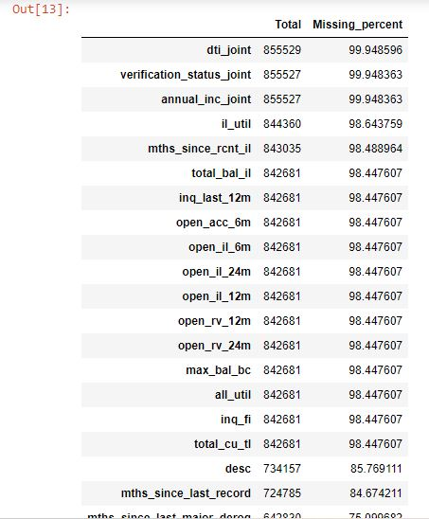

The missing values can be filled by using various mathematical techniques i.e. Mean, Median, Mode, KNN imputation.

I remove the following columns

**dti_joint','verification_status_joint','annual_inc_joint','il_util','mths_since_rcnt_il',**

**'total_bal_il','inq_last_12m','open_acc_6m','open_il_6m','open_il_24m','open_il_12m',**

**'open_rv_12m','open_rv_24m','max_bal_bc','all_util','inq_fi','total_cu_tl','desc','mths_since_last_record','mths_since_last_major_derog','mths_since_last_delinq','next_pymnt_d','tot_cur_bal',**

**'tot_coll_amt','total_rev_hi_lim','emp_title'**

Because these feature have most missing value.

## 2.2 Phase II - Feature Engineering

I applied the feature Engineering on on last_credit_pull_d feature to extract the month and year from the date.

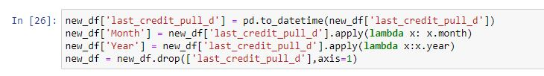

**2.3 Data Dictionary:**- A data dictionary is a list of key terms and metrics with definitions, a business glossary. While it is sounds simple, almost trivial, its ability to align the business and remove confusion can be profound. In fact, a data dictionary is possibly one of the most valuable artifacts that a data team can deliver to the business.

**Please refer below file for Data Dictionary:**

## 

## 2.4 Exploratory Data Analysis:

Exploratory data analysis (EDA) is an approach to analyzing data sets to summarize their main characteristics, often with visual methods.

Some of the EDA perform are as follow:

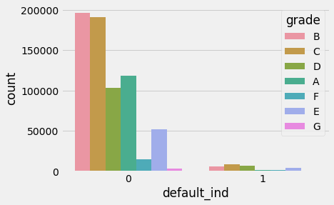

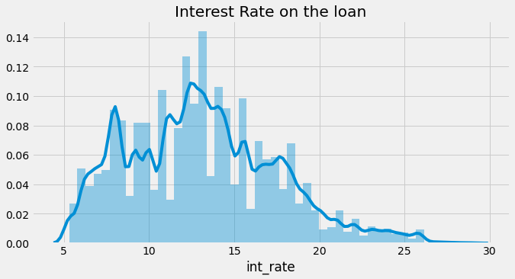

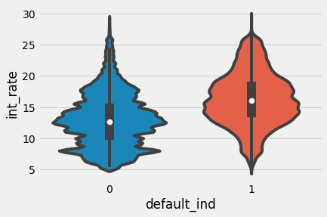

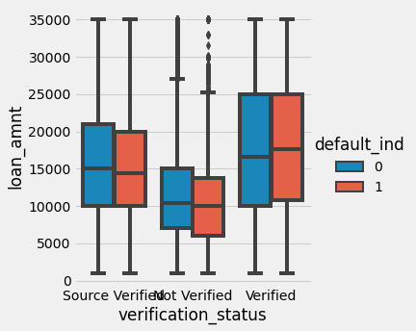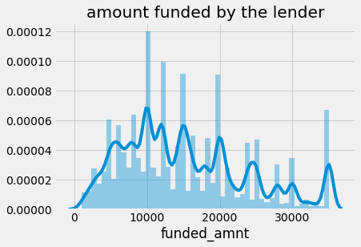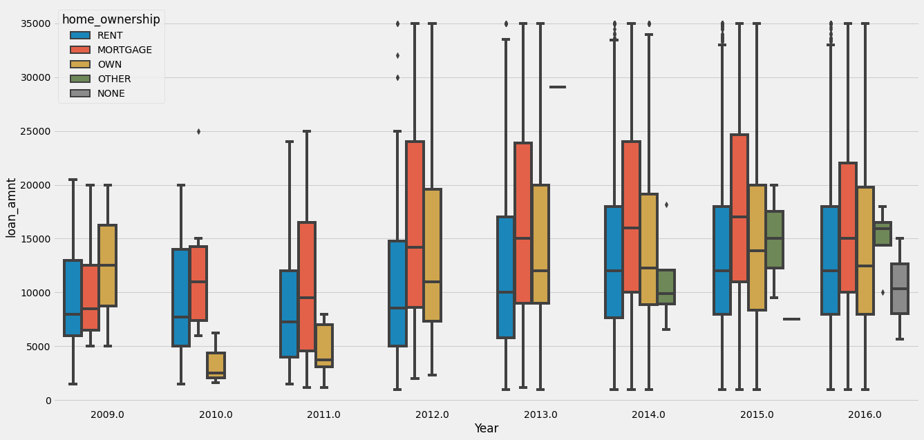

# CHAPTER 3: FITTING MODELS TO DATA

## 3.1.1 Logistic Regression:

Logistic regression is a statistical model that in its basic form uses a logistic function to model a binary dependent variable, although many more complex extensions exist. In regression analysis, logistic regression (or logit regression) is estimating the parameters of a logistic model (a form of binary regression). Mathematically, a binary logistic model has a dependent variable with two possible values, such as pass/fail which is represented by an indicator variable, where the two values are labeled "0" and "1". In the logistic model, the log-odds (the logarithm of the odds) for the value labeled "1" is a linear combination of one or more independent variables ("predictors"); the independent variables can each be a binary variable (two classes, coded by an indicator variable) or a continuous variable (any real value). The corresponding probability of the value labeled "1" can vary between 0 (certainly the value "0") and 1 (certainly the value "1"),

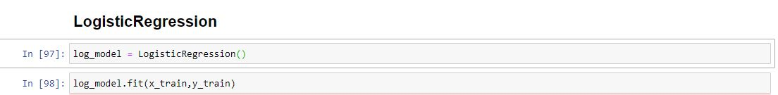

## 3.1.2 XGBOOST ALGORITHM:

XGBoost is an optimized distributed gradient boosting library designed to be highly efficient, flexible and portable. It implements machine learning algorithms under the Gradient Boosting framework. XGBoost provides a parallel tree boosting (also known as GBDT, GBM) that solve many data science problems in a fast and accurate way. The same code runs on major distributed environment (Hadoop, SGE, MPI) and can solve problems beyond billions of examples.

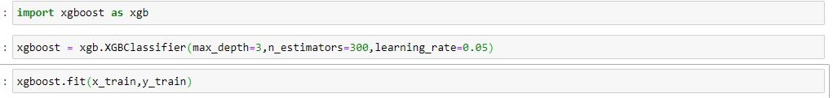

## 3.1.3 Random Forest Classifier:

Random forests or random decision forests are an ensemble learning method for classification, regression and other tasks that operate by constructing a multitude of decision trees at training time and outputting the class that is the mode of the classes (classification) or mean prediction (regression) of the individual trees.Random decision forests correct for decision trees' habit of overfitting to their training set.

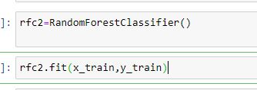

## 3.1.4 Decision Tree Classifier:

A decision tree is a decision support tool that uses a tree-like model of decisions and their possible consequences, including chance event outcomes, resource costs, and utility. It is one way to display an algorithm that only contains conditional control statements.

Decision trees are commonly used in operations research, specifically in decision analysis, to help identify a strategy most likely to reach a goal, but are also a popular tool in machine learning.

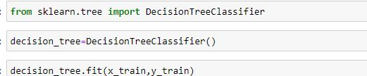

CHAPTER 5: KEY FINDINGS

Below table provides a snapshot of the various models which the business can choose from based on the pros and cons of each model.

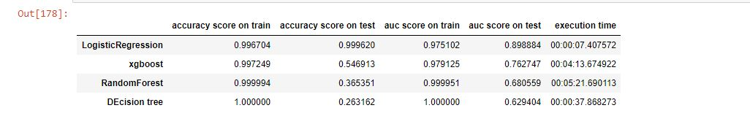

CHAPTER 6: RECOMMENDATIONS AND CONCLUSION

Hence based on key finding the conclusion is that Logistic regression model is the best fit model for this dataset to predict the customer reorder ratio

logistic regression model having model accuracy as 99% on train data set and accuracy on test also 99% and AUC_ROC score on train also 97% and AUC_ROC score on test also 87% to predict.

CHAPTER 7: REFERENCES

Imarticus

Towardscience

Wikepedia

Analytic vidhya blog